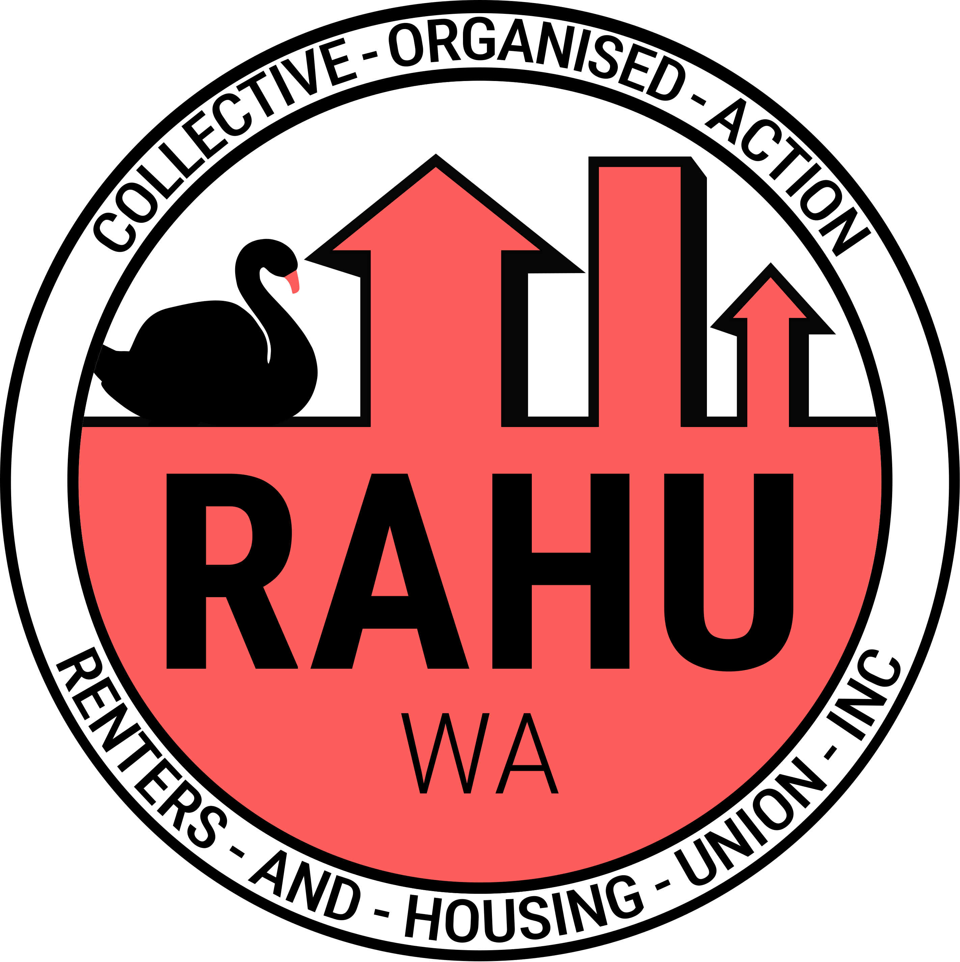
Renters And Housing Union (RAHU) Western Australia Branch Emergency Statement

URGENT: On Eviction of Beananging Kwuurt Institute

Statement:
The Renter’s and Housing Union (RAHU) Western Australia branch wishes to express significant concern and opposition regarding the impending evictions of the Beananging Kwuurt Institute (BKI) from the property of the Uniting Church Australia.

Located in Queens Park, near Welshpool, the BKI property was historically a mission site known as Sister Kate's Children's Home; It was here where grave injustices, abuse, and crimes were perpetrated during the Stolen Generations era.

Since that time, the property has been transformed into a community center that provides invaluable contributions, support, and services to Indigenous people. The artwork produced by BKI has been showcased in many place in Western Australia and some has even been sent overseas. Many women have emerged from BKI as successful artists. Bev Burns, a spokesperson for some of the BKI women, notes, “We offer art lessons for connection to Country… through art, we heal and deal with the past, and express our thoughts when words fail.”

BKI is also self sufficient. Being able to operate without any funding from the Uniting Church Australia.

Nonetheless, in May 2024, the Uniting Church decided to close BKI and evict them from the property. The initial eviction was scheduled for June 2024, but the date has since been postponed to December 12, 2024. The Uniting Church remains resolute in its decision to proceed with the eviction.

The Uniting Church doesn’t have any future plans for the property after BKI is evicted.

RAHU WA calls upon the Uniting Church Australia to reconsider this decision and allow BKI to continue its self-sufficient operations, and positive community service. Community outrage will follow if the church continues to commit to this path of eviction of BKI.

RAHU WA strongly denounces the church's ongoing pursuit of eviction. We wish to highlight the church’s historical involvement in the Stolen Generations and drawing parallels to past injustices faced by Indigenous people in Western Australia, including the Oombulgurri evictions and demolitions.

RAHU WA also calls upon our government, members of Parliament and leaders to intervene, with specific call out to:
- The City of Canning Local government
- State representative for Cannington, William (Bill) Joseph Johnston MLA
- Federal Representative for Swan Zaneta Mascarenhas.
- Members of the Eastern Metropolitan Region of the West Australian Upper House
- Senators representing WA
to speak out, intervene, and prevent the eviction.

RAHU WA remains committed to collaborating with the community and BKI to oppose these evictions.
Quote attributable to Sadie Ward, RAHU WA Delegate:
“Beananging Kwuurt Institute is being kicked out by Uniting Church who owns the land and have no plans to continue the service. BKI runs several vital services, some supporting kids just coming out of Banksia Hill. They provide a lot of support to homeless folks and those doing it rough.“

Quote Attributable to BKI supporter:
“This place is a key example of a third place. They offer help and community to any who ask regardless of race or religious affiliation, and with support could blossom into something incredible.“

For further media inquires:
0437227463
media@rahu.org.au
wa@rahu.org.au

https://www.abc.net.au/news/2018-07-29/brutal-legacy-of-sister-kate-indigenous-childrens-home/10034434
https://nit.com.au/30-10-2024/14553/exclusive-indigenous-womens-organisation-alleges-millions-allocated-for-service-at-sister-kates-site-were-squandered
https://nit.com.au/30-10-2024/14553/exclusive-indigenous-womens-organisation-alleges-millions-allocated-for-service-at-sister-kates-site-were-squandered
https://www.abc.net.au/news/2023-05-30/nt-stolen-generations-compensation-croker-island-mission/102403444
https://www.amnesty.org.au/oombulgurri-demolitions-your-questions-answered/
Alanna Clohesy, Samantha Rowe, Matthew Swinbourn. Lorna Harper, Donna Faragher and Brian Walker
Michaelia Cash, Matt O'Sullivan, Linda Reynolds, Dorinda Cox, Fatima Payman, Sue Lines, Glenn Sterle, Varun Ghosh, Jordon Steele-John, Louise Pratt and Dean Smith

